**Select Advanced Modeling Options**

Ecosystems and management of them are complex. As you model you will most likely ask “what if I could [fill in the blank] in the model?”. Addressing all potential scenarios is beyond the scope of this tutorial, but we did want to point out some functions on this page that will help you:

* Implement “limits”. For example you may want to ask “what would happen if we applied 1,000, 2,000 or 3,000ha of controlled burning per year compared?”
* Add variability to annual disturbance probabilities. In other words, an ecosystem may experience an insect that has relatively predictable population cycles, with maximum population size every 7 years. How would you do that in SyncroSim?
* Apply and track attributes. You may know that a “value” of interest (e.g., a beetle species) occurs exclusively within a state class. It is possible to track these values in the software.
* Spatial modeling. SyncroSim has robust spatial modeling capabilities

This section briefly describes a sample of the advanced modeling options available in ST-Sim. We will just skim the surface of the possibilities to begin your work in the ST-Sim platform. To see more advanced modeling topics, and for more detailed information visit [www.apexrms.com](http://www.apexrms.com) or <http://docs.stsim.net>. For the latest screen captures showing the details of these options please visit the websites above to ensure you are seeing the latest version of the software. We also encourage you to explore other advanced modeling options once you are familiar with the platform, but to not jump too quickly into advanced modeling options or complex models. This can cause confusion and retard progress toward your goal.

**Transition Targets**

The **Transition Targets** Property allows the modeler to define targets/limits for the area to transition over time across the landscape for specific types of transitions. Targets can be set up as operational constraints based on area, or when costs are added on available budgets. The target can be specified by iteration, BpS, and timestep.

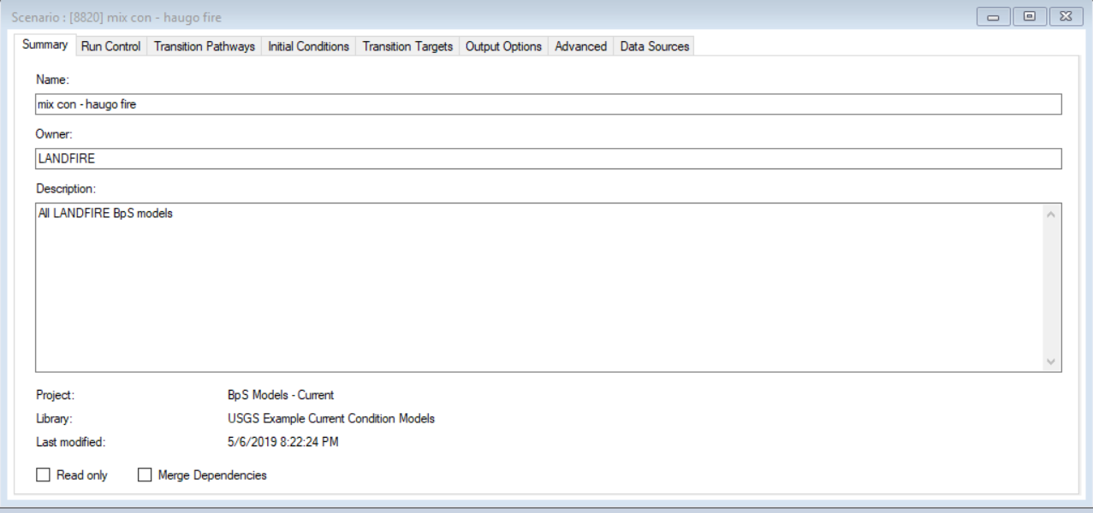

For example, you can limit the amount of any probabilistic transition/disturbance to a specific number of acres in each timestep and iteration for a BpS based on the budget you expect to be available, or on the operational constraint created by your organization’s capacity or regulatory issues. If you expect your budget or capacity/capabilities to increase over time you can increase the target over the timesteps. This option is available for all disturbances/probabilistic transitions.

Note that you can also set transition targets using a probability distribution (such as Normal, Uniform or Beta) if you believe the transition target constraint will vary over time according to distribution rather than a specific amount. Once this option is selected, you can also specify the standard deviation, minimum and maximum values for the distribution, and how often to draw a new value from the distribution.

**Transition Multipliers**

It is useful to be able to vary transition probabilities over time not just operational limits (see **Transition Targets**). Using transition multipliers allows the user to modify how often a probabilistic transition/disturbance/change will be imposed on a pixel across timesteps or iterations. Suppose that under different climate change scenarios, transition probabilities will vary over time., e.g., fire will increase, succession/growth will speed up or slow down, strata will change locations on the landscape, etc. The Transition Multiplier Values property specifies multipliers to be applied to transition probabilities over the course of the simulation, e.g., increase the amount of thinning by 50% for the first 10 timesteps, and then increase by 100% for the remaining timesteps. The user can also utilize an expected distribution of multipliers they create from past events or recent information, or they can select the Beta or Normal statistical distributions packaged with the software. Using statistical distributions may require additional information such as minimum, maximum and standard deviation.

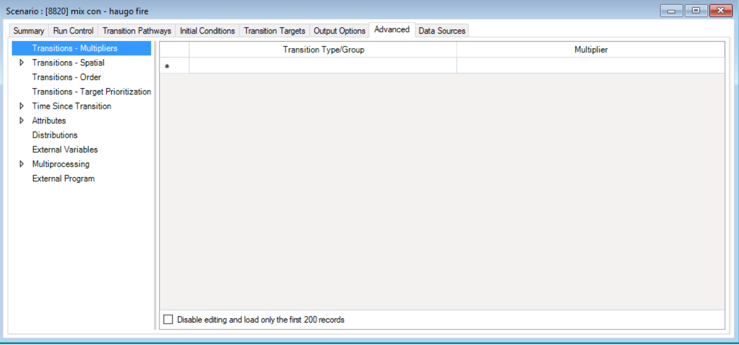

This video provided by ApexRMS provides a description of how to use Transition Multipliers.

*Temporal Variability in Transitions*

<https://www.youtube.com/watch?v=TV4p4NspIME&list=PL57N-QiM8Rinz-yTm5HX8tnlkEmh44sQG&index=7>

A second application of the Transition Multiplier option is when the modeler wishes to incorporate statistical variability into the model parameters over the timesteps and iterations because the actual value is unknown or varies across timesteps. For example, the probability of fire can vary from year to year. We can use transition multipliers to sample fire probabilities from a fire history we provide, or from a statistical distribution instead of using a single probability over time or varying the probability by specific amounts. These videos describe how the Transition Multiplier section has been utilized with LANDFIRE BpS models.

* *LF Short: Simulating the Historical Range of Variability with LANDFIRE BpS Models*<https://www.youtube.com/watch?v=86AC9e8H9vg>
* *Simulating the Historical Range of Variability in Fire-Adapted Forests Using LANDFIRE* <https://www.youtube.com/watch?v=d855SupanQU>

**State and Transition Attributes**

Suppose that you wish to estimate values that are associated with various model states and/or model transitions. If so, attributes represent can be used to roll up simulation results according to areas aggregated by either state classes or transitions. For, example, how much smoke would be produced in a surface fire in a specific seral state (add an attribute reflecting average smoke production to surface fire transition)? What is the total habitat score for a particular species under each simulated scenario (add a habitat value score attribute to each seral state)? These values can then be summarized over the simulations to provide additional results that can be compared across scenarios? Do I produce more or less smoke in this scenario? Do I increase or decrease the habitat score in this scenario?

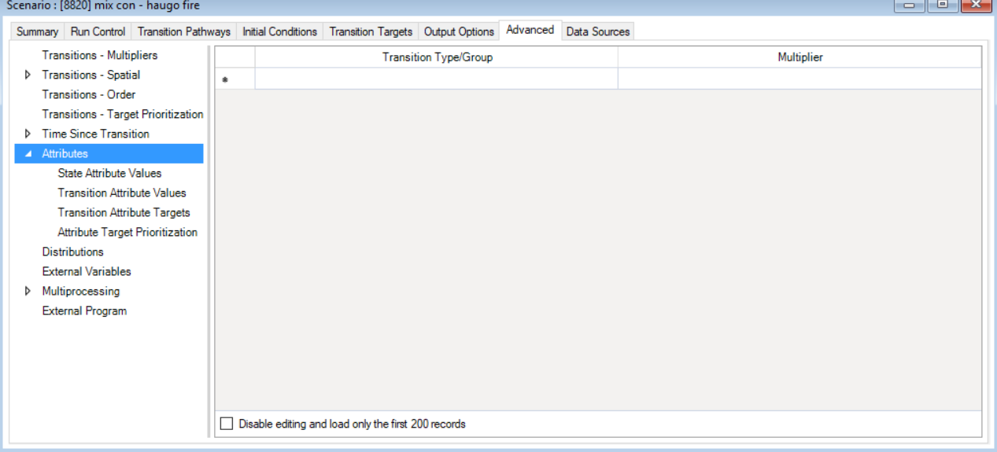

Note that these modeling options can be combined: Transition Targets, Transition Multipliers and Attributes. A video from Apex RMS describes one application

<https://www.youtube.com/watch?v=b3MQfyYE6ZQ&list=PL57N-QiM8Rinz-yTm5HX8tnlkEmh44sQG&index=9>

We remind and encourage you to progress slowly and to use advanced modeling options step-by-step and with care so you can understand your model, explain the results and troubleshoot problems. As the model increases in complexity, all these things get more difficult.

**Spatial Models**

Thus far, we have been demonstrating how to modify and apply STSMs aspatially. However, ST-Sim allows the user to run these models using spatial functionality if the required data sets and information are available. A map of initial conditions can be specified as input to the STSM which can then produce a post-simulation output map. In addition, some “contagion” functionality is available that allows for disturbances to “spread” across the simulated from a starting point (fire, insects/disease, etc.). Running these models spatially can provide significant value, however, there are two cautions:

* Significant input information is required to make this spatial option useful, and
* Do a thorough review of your model aspatially to ensure you are satisfied before you move to the spatial option.

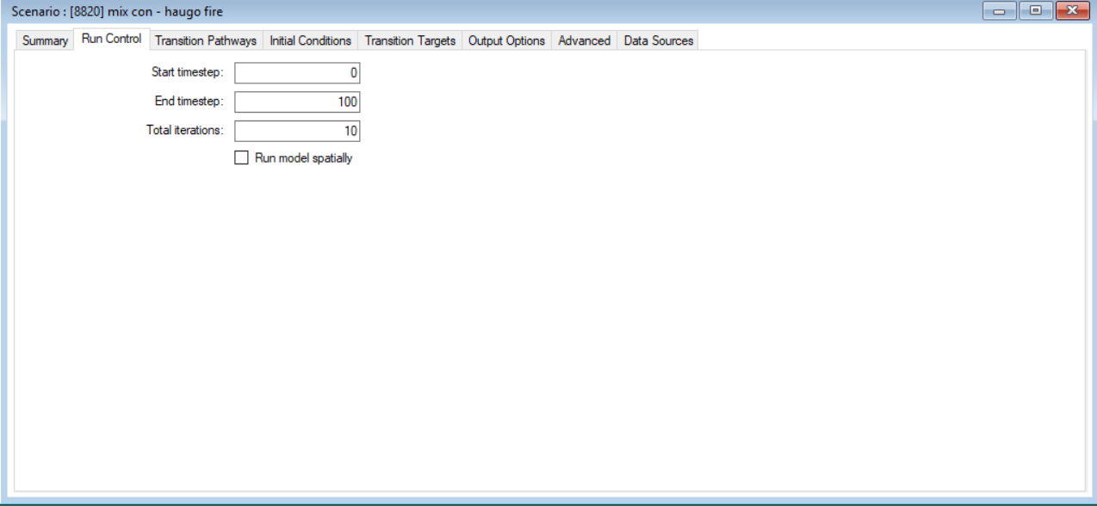

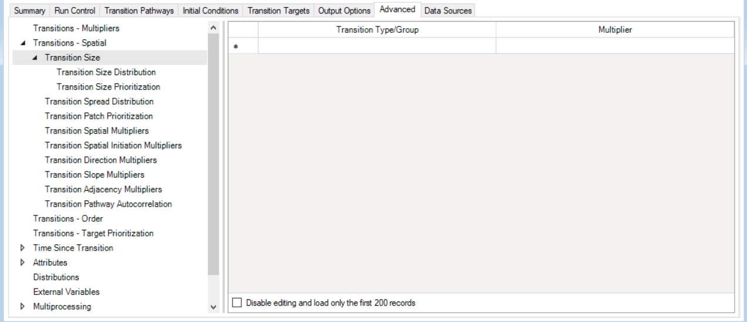

Follow this link to a video that demonstrates how to setup and run spatial ST-Sim STSM.

Spatial Modeling Using ST-Sim

<https://www.youtube.com/watch?v=xHku6jltFeA&list=PL57N-QiM8Rika1HvXAdxl6pPOVGjsw-WY&index=3>

Note that incorporating spatial functionality increases the complexity of the model as well as the modeling options so additional training or support from Apex RMS may be warranted as you move toward spatial implementation.

*I THINK THERE ARE CONNECTIONS TO THE CLIMATE CHANGE TAB (AND PERHAPS OTHERS) FROM KIM THAT I NEED TO IDENTIFY AND ADD LINKS.*